1. Create project structure like this:

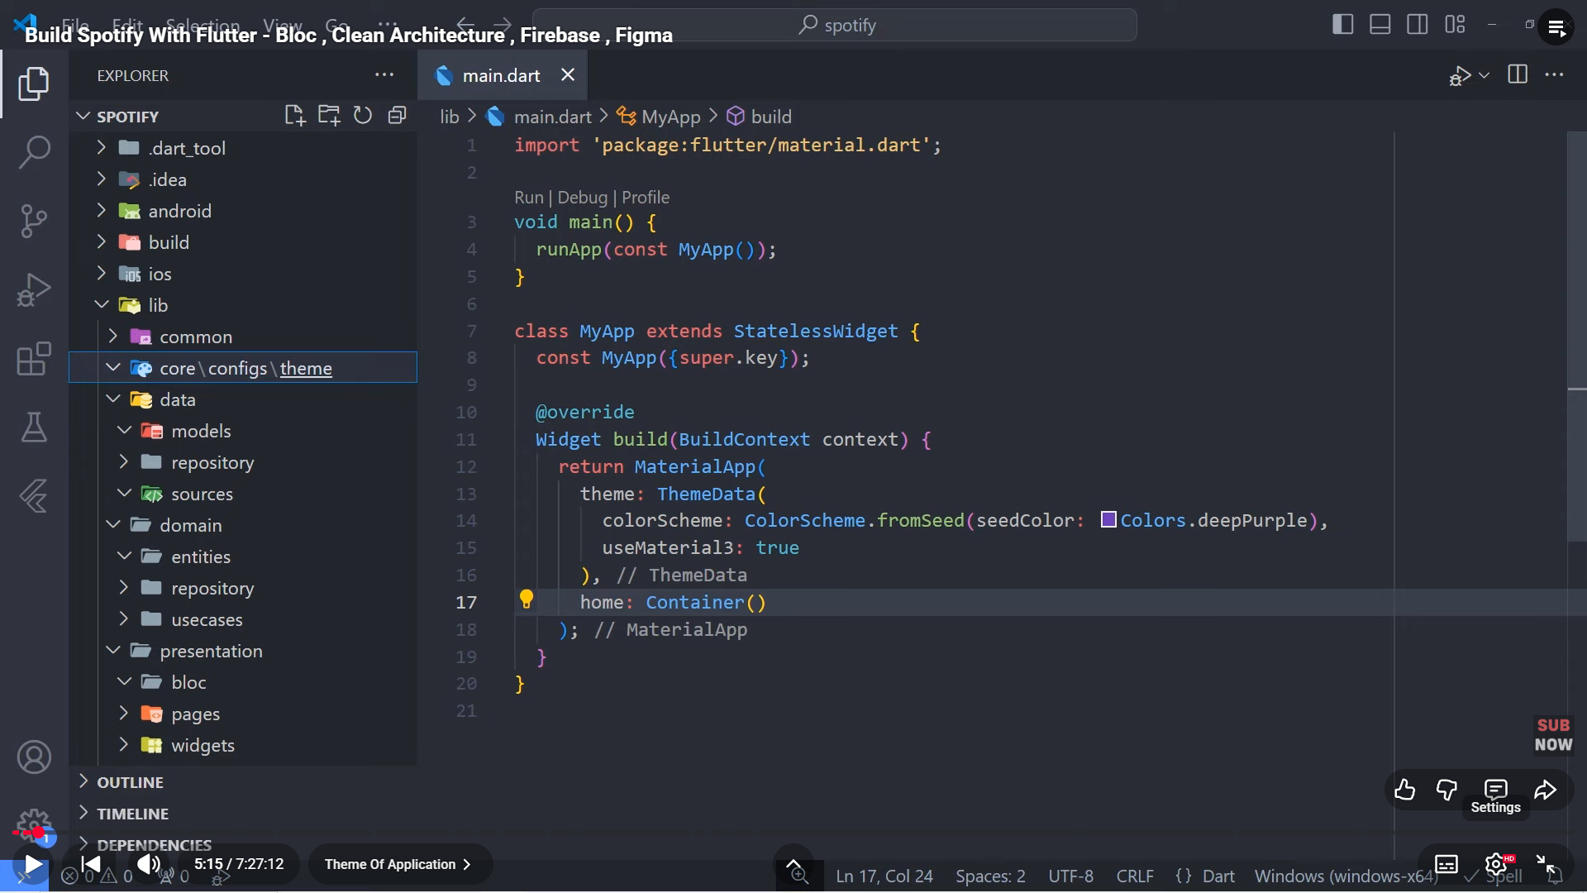

1. App_colors:

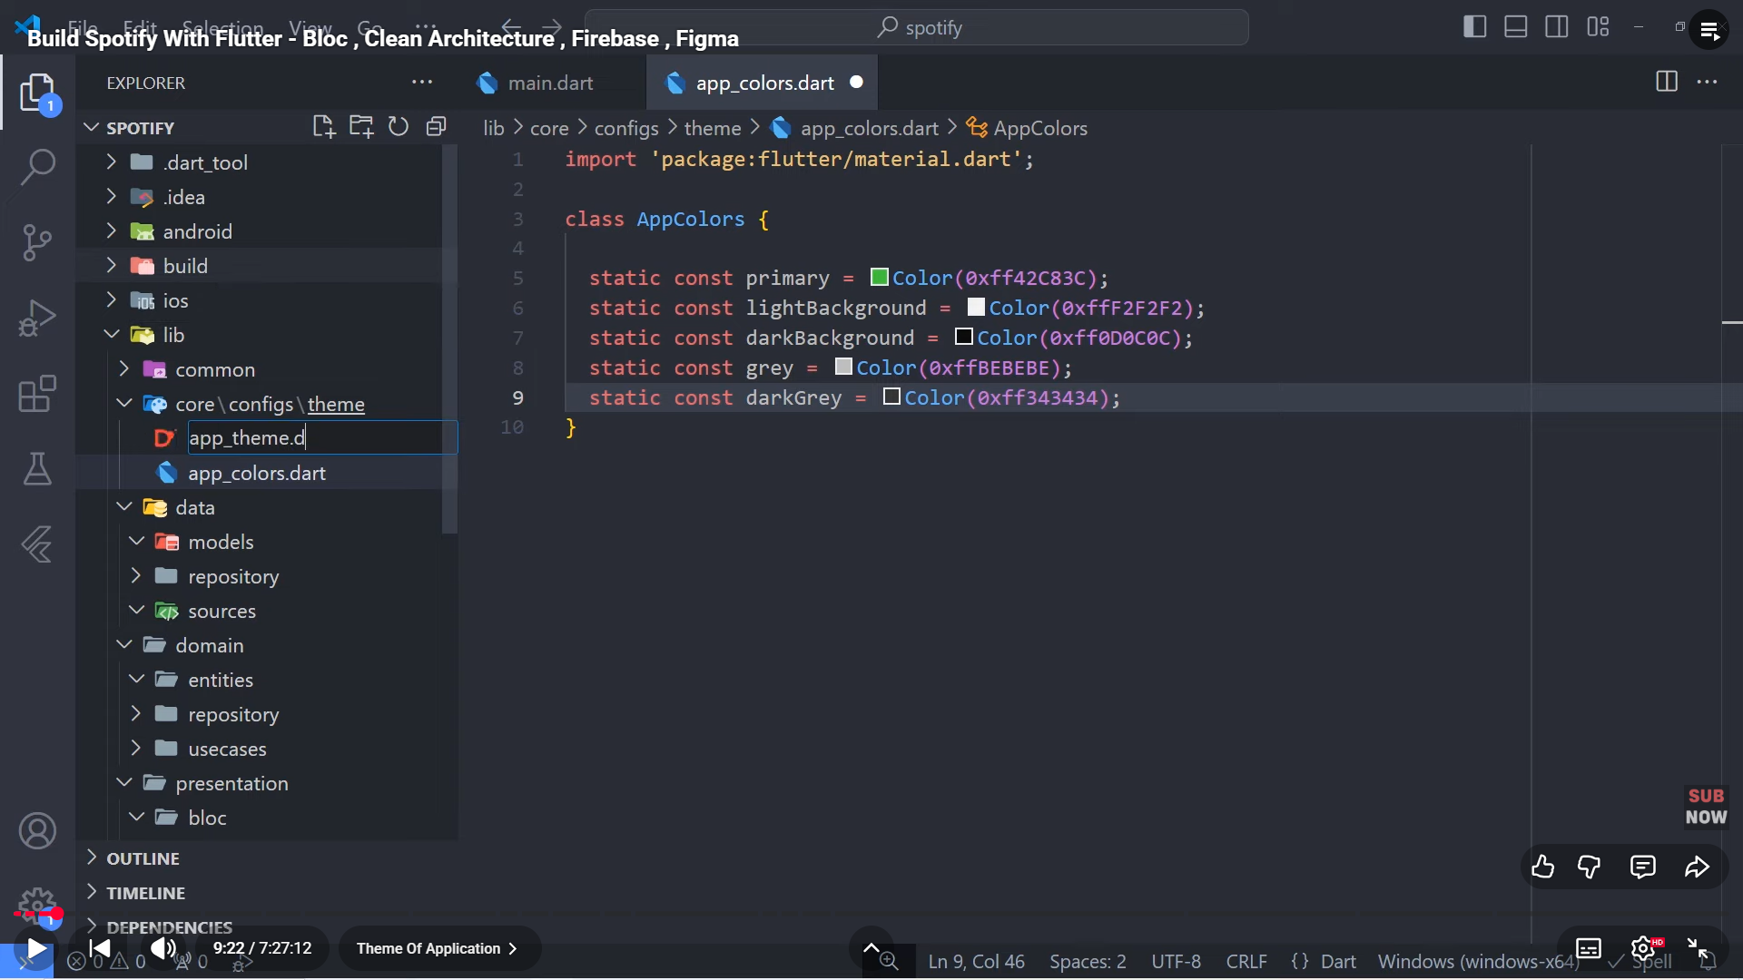

1. App_theme:

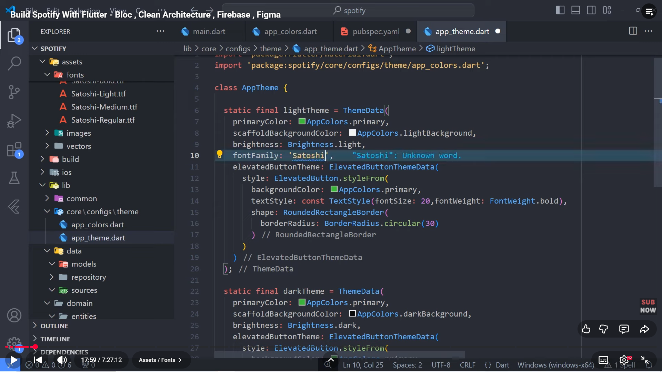

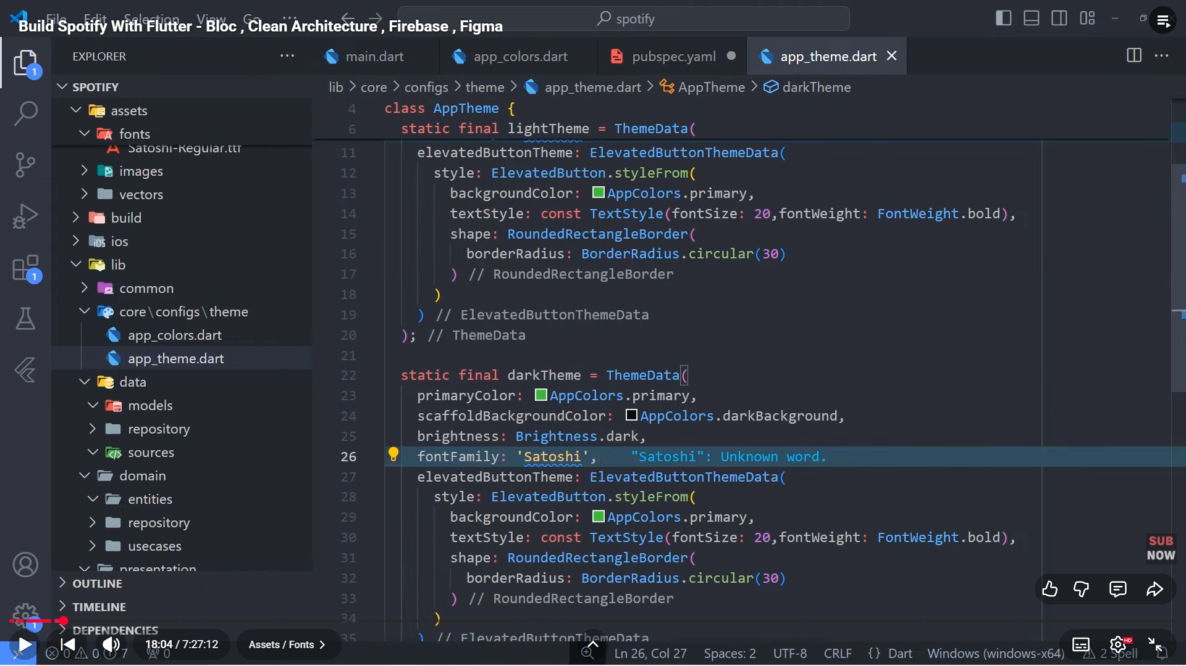

1. Configure:

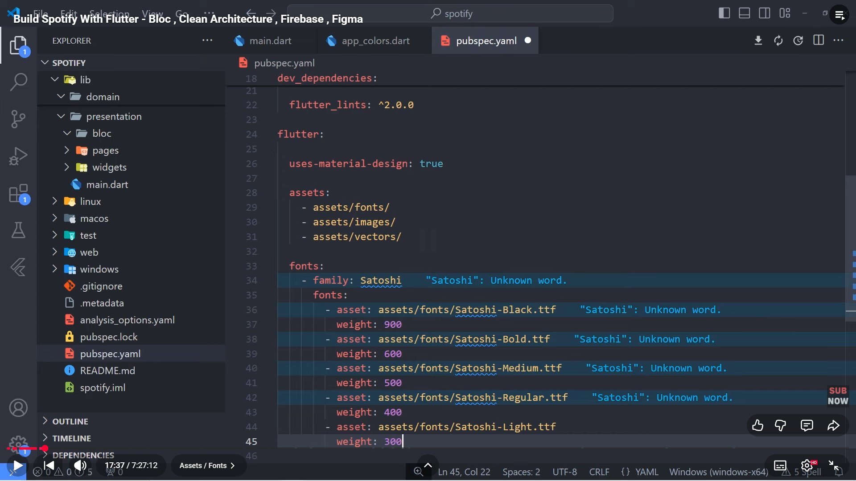

1. Create folder presentation/splash/bloc, pages/splash, widgets and assets inside core/configs

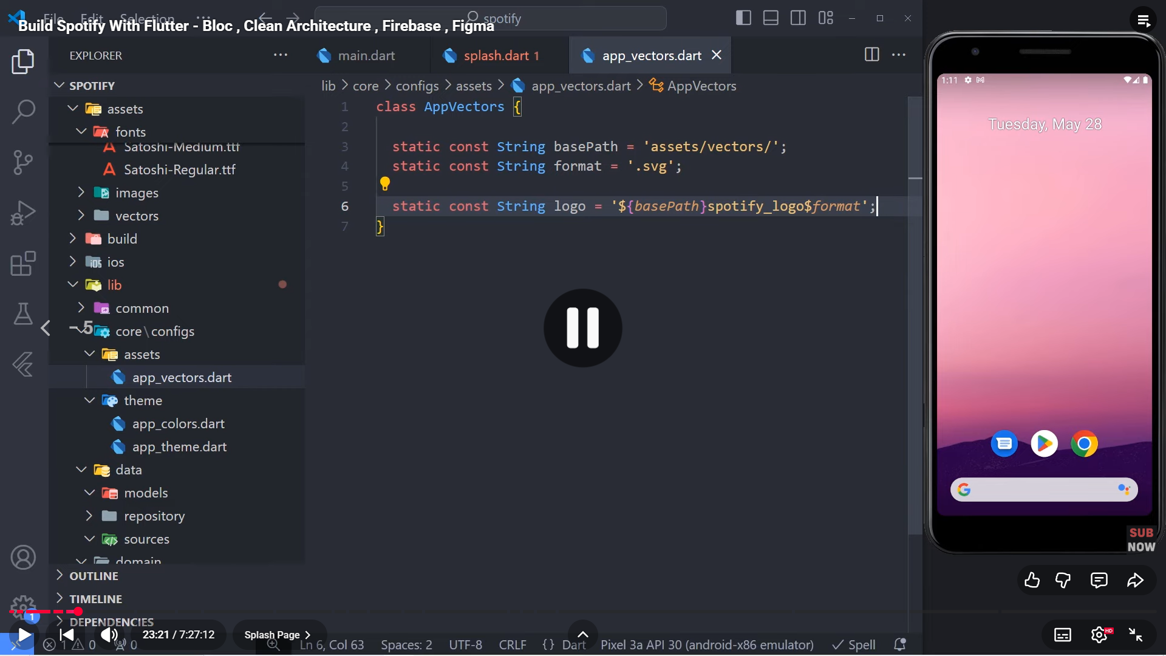

1. Add flutter_svg: in pubspec.yml after cupertino_icons: ^1.0.8
2. Create future function inside splash called redirect to startPage
3. Create file widgets/button/basic_app_button inside common

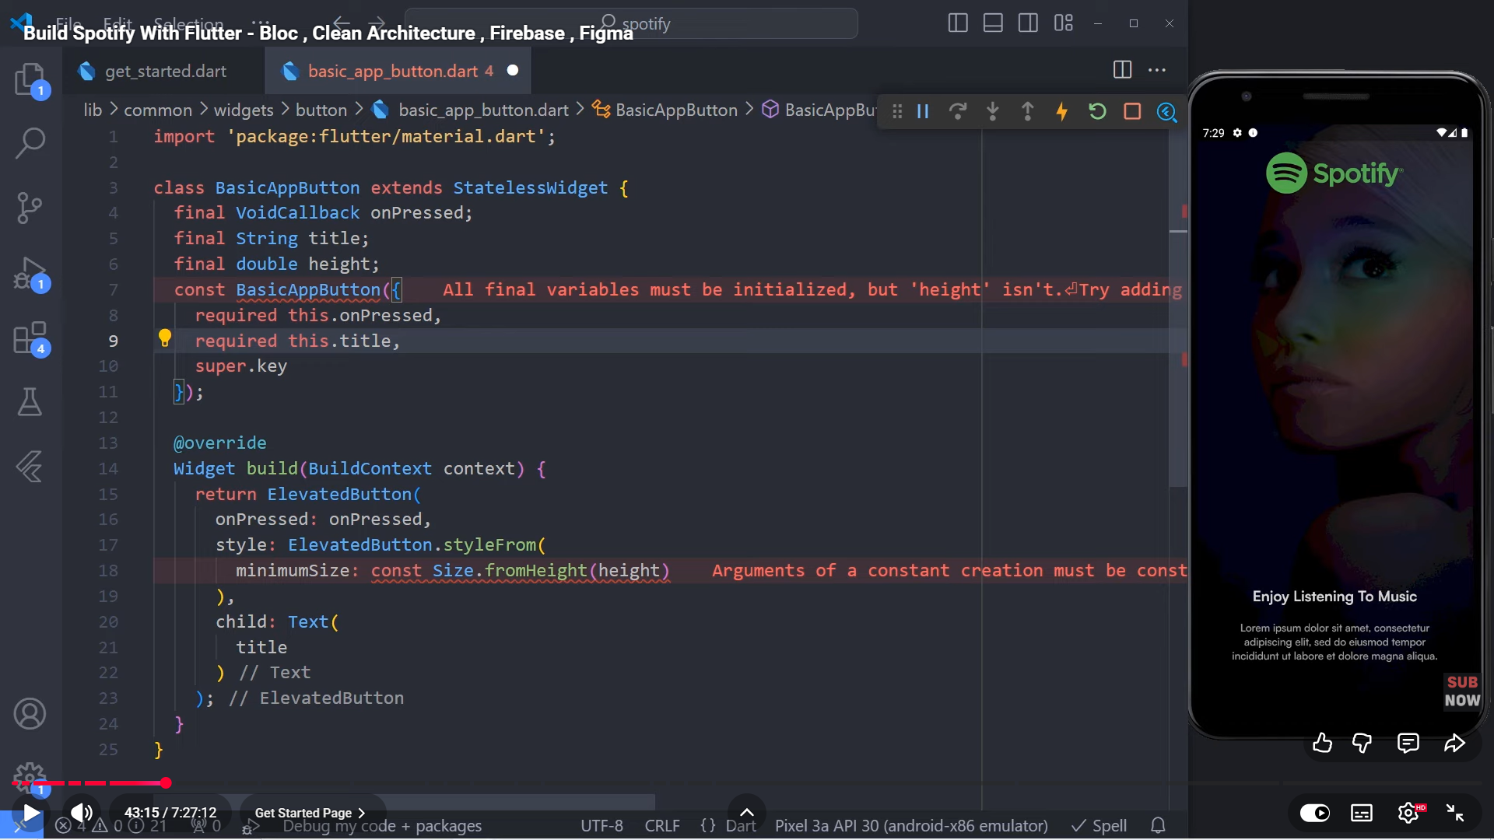

1. Get started will be like this:

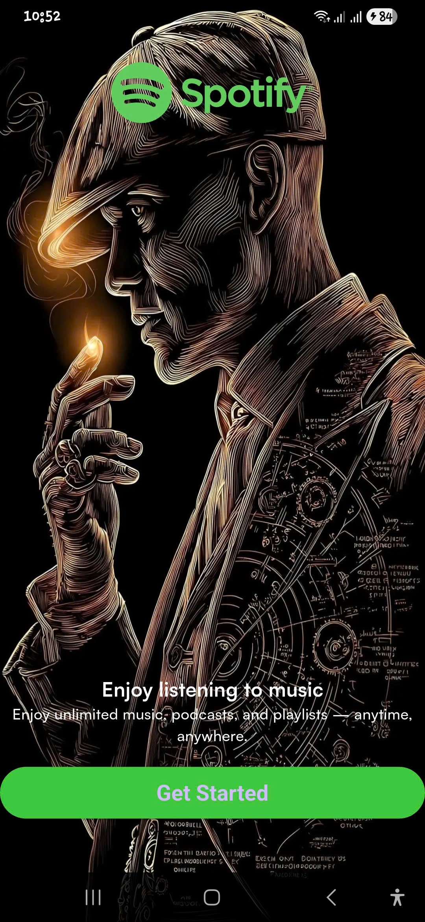

1. Create folder choose_mode in presentation
2. Choose_made will be like this:

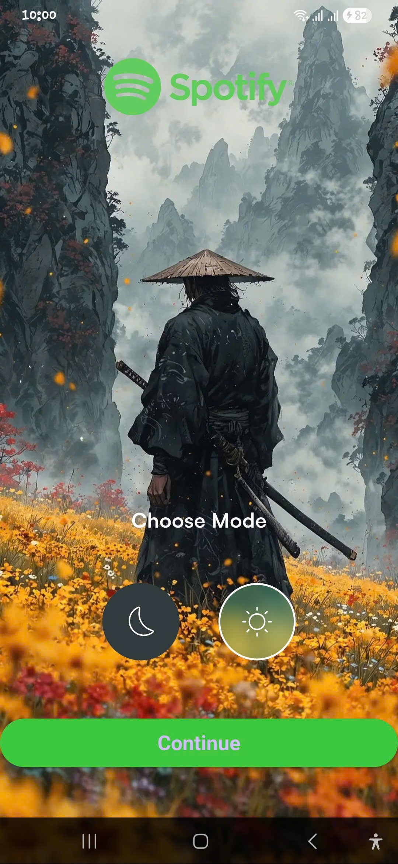

1. Use bloc to manage state:

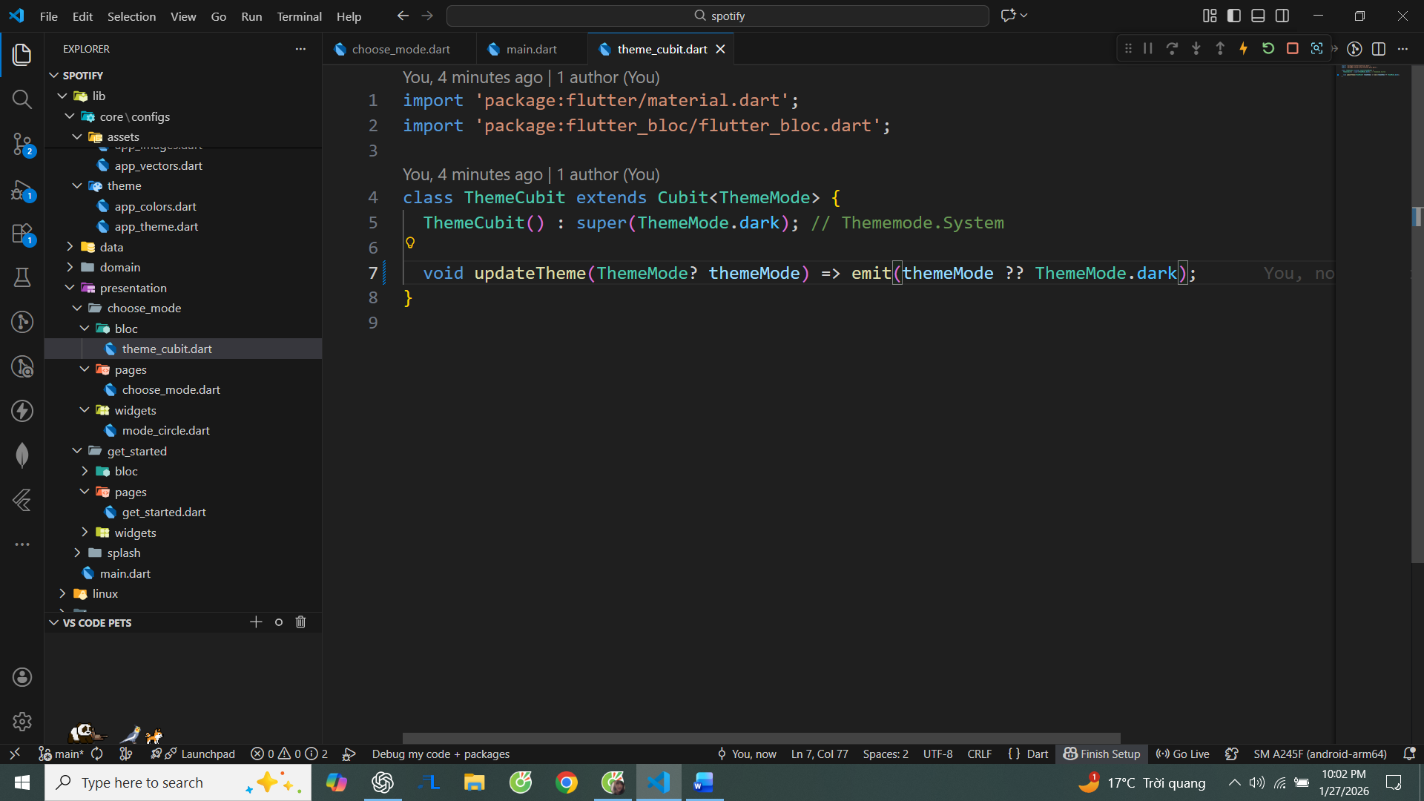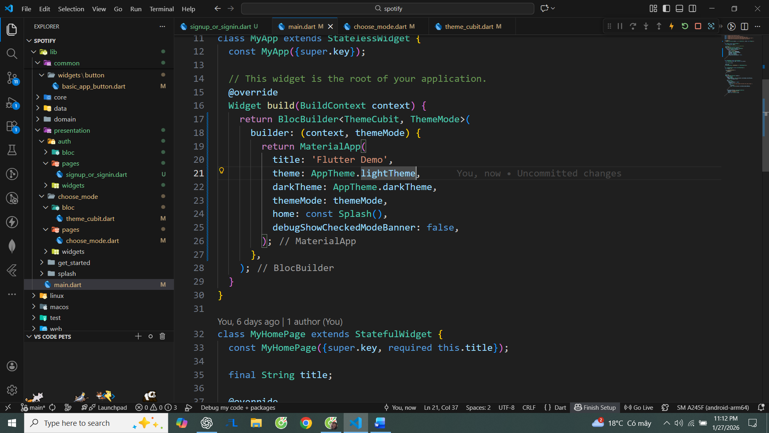

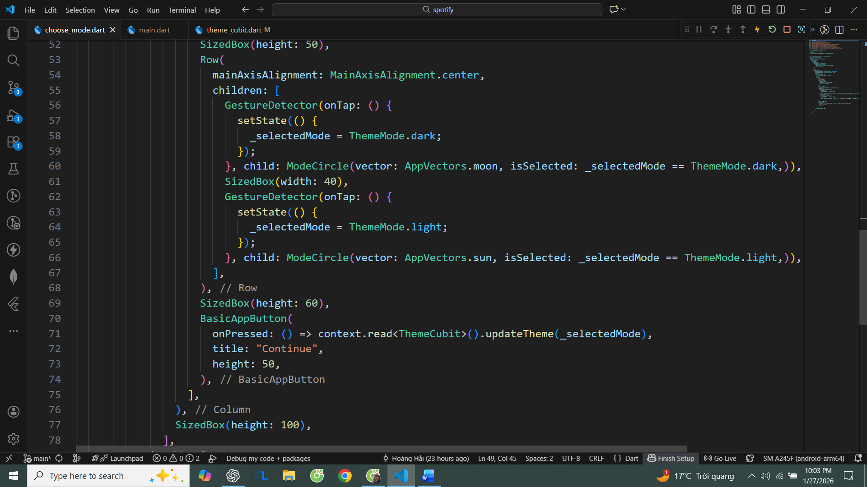

1. ModeCircle:

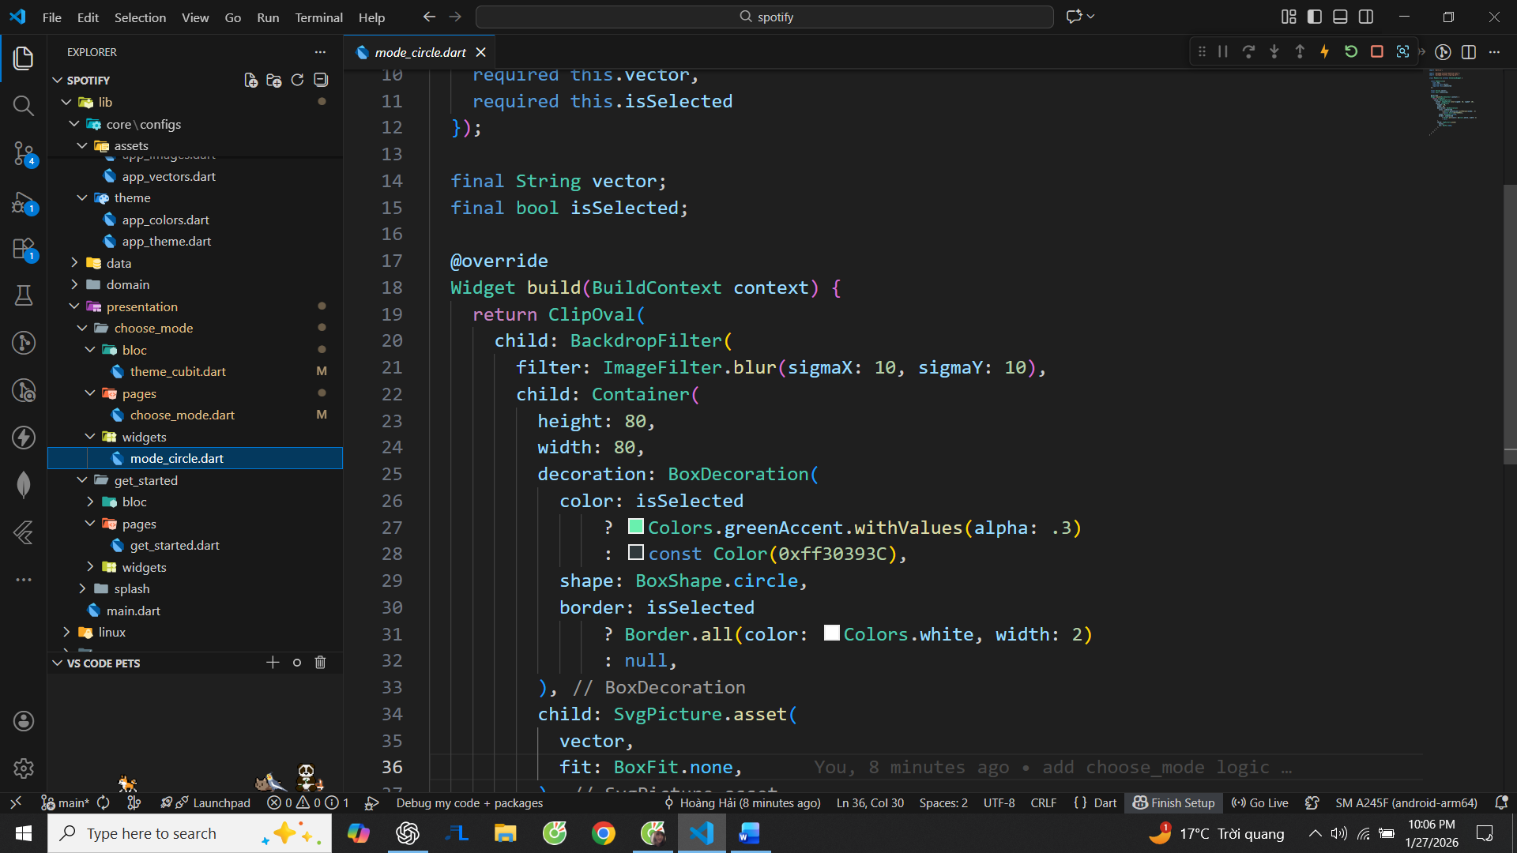

1. Create folder auth in presentation and create signup_or_signin.dart
2. Create folder helpers in common:

